

**Advance Web Application Development**

**Task 9**

**Use of on Click Event**

Instructor:

**Tahir Shafi**

Prepared By

**Noman Asif**

**Code**

**Click_event.html file code**

<!DOCTYPE html>

<html lang="en">

<head>

  <meta charset="UTF-8" />

  <meta name="viewport" content="width=device-width, initial-scale=1.0" />

  <title>Task 9 - Click Event</title>

  <!-- Call an External Style Sheet -->

  <link rel="stylesheet" href="style.css">

</head>

<body>

  <!-- Task 9 -->

  <!-- Change the color of the text when it is clicked. -->

  <div class="text-container">

    <h1 id="myText">Click me! to change my color</h1>

  </div>

</body>

</html>

**Style.css file code**

.text-container{

text-align:center;

margin-top:80px;

}

#myText:hover{

  cursor: pointer;

}

#myText:active {

  color: red;

 cursor: pointer;

}

**Result before click**

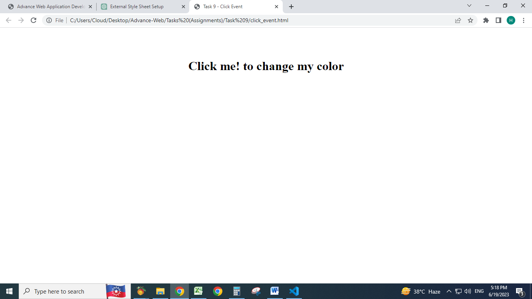

**Result After Click**

